Tri-Sync Repair Kit V.101217
Tri-Sync Pin Removal and Replacement of LED and Batteries Using M&R Item Number:
8L50045-REP-Kit-EM
Remove / Replace Pins, Screw, Registration Block and LED Wire Assembly.
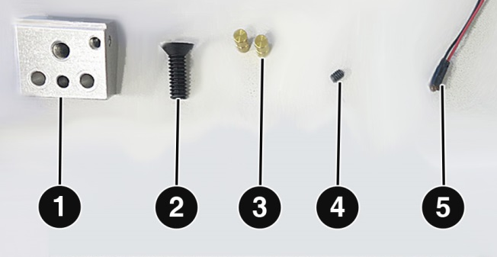
Items in Tri-Sync Repair Kit:
1 - Registration Block (1) M&R part # 8L50045-A;
1 - Flat Head Slot Screw (2) M&R part # 3055037;
2 - Brass Pin (3) M&R part # 8150669;
1 - Set Screw (4) M&R part # 3007006; and
1 - LED Indicator Green (5) M&R part # 1044025.
Items Required:
1 – Flathead Screwdriver;
1 – Wire Cutters;
1 – 1/16” Hex Wrench;
1 – 1/8 Hex Wrench; and
1 – Hammer and a 3/16” Pin Punch.
- Remove Metal Bracket (1) by removing six Cap Screws (2) using a 1/8” hex wrench to gain access to Registration Blocks (3) and Battery Holder (4).
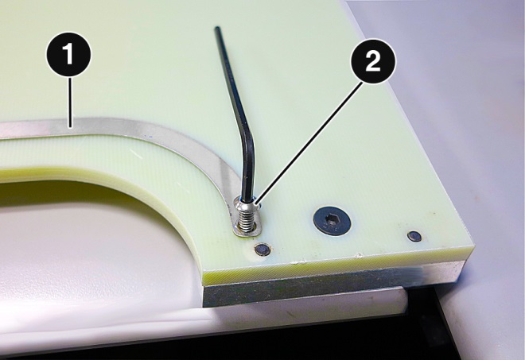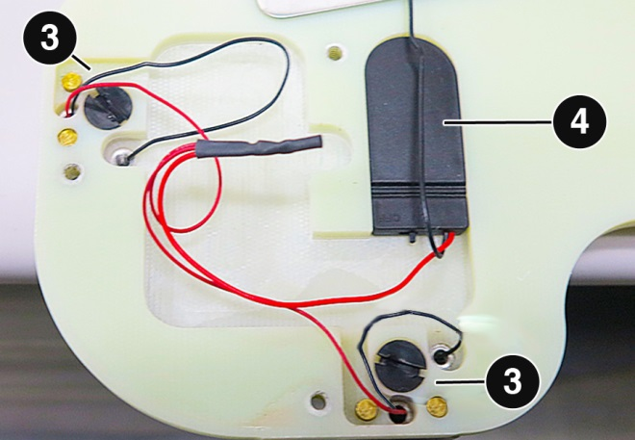
- Remove the two Brass Pins (5) using a hammer and a 3/16” pin punch. After cutting the red wire at the solder connection, use a flat head screwdriver to remove the Slot Screw (6) and Registration Block from the Tri-Sync pallet. Disconnect the black LED Wire from Registration Block using a 1/16” hex wrench.
Note: Use care to avoid damaging the Tri-Sync pallet and Brass Pin holes.
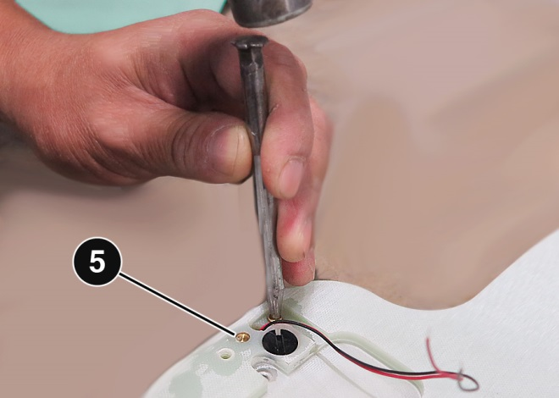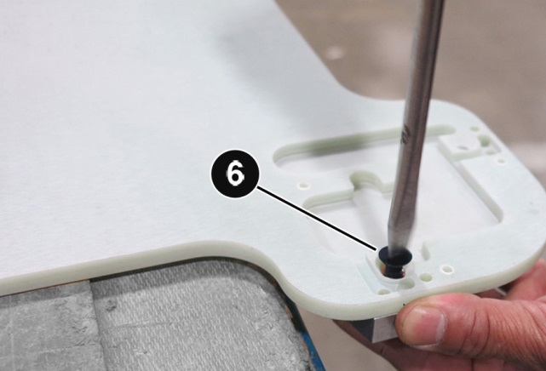
Page 1 of 2
Tri-Sync Repair Kit V.101217
- Insert new Brass Pins, Registration Block and Slot Screw. Insert the new LED wire assembly from the bottom of the registration block to the top of the pallet. Solder all red wires together and insert black wire to the ground position using a 1/16 hex wrench.
Note: The soldered wires must be insulated with electrical tape or shrink tubing before attaching Metal Bracket.
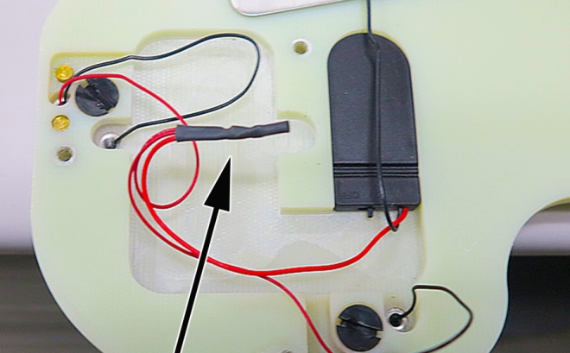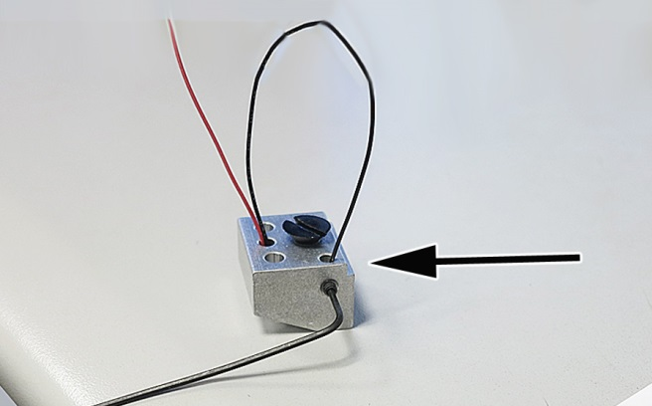
Replace Battery
Items Required:
1 – Phillip head Screwdriver; and
2 – M&R part number 1005048 (Lithium Battery 3V).
- Carefully pull out the battery holder and remove the two screws (1). Open battery holder and insert the new batteries (2), make sure the batteries positive and negative polarity indicators correspond with battery holder. Re-insert screws and place battery holder back into to pallet, with screws facing down. Before attaching Metal Bracket make sure battery holder switch (3) is in the on position.
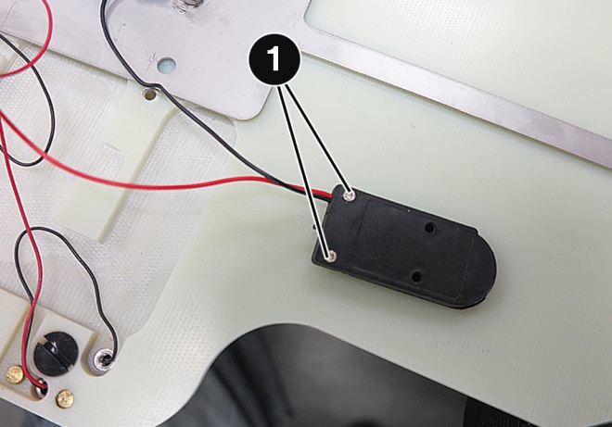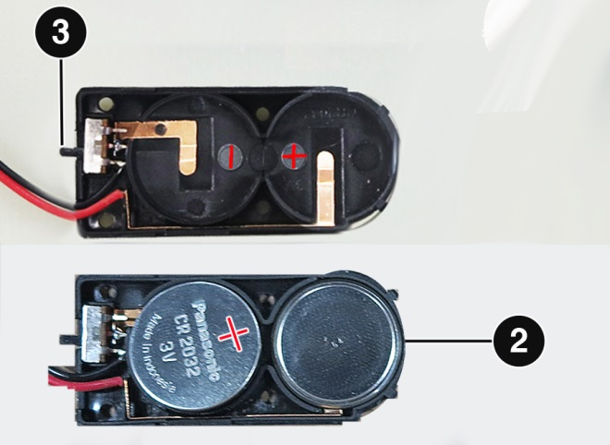
- Re-attach Metal Bracket (1) with five hex screws (2) (M&R part # 3001059), one hex screw (3) (M&R part #3009353) inserted in the far right position.
Note: Route wires so to not damage them when re-attaching Metal Bracket.
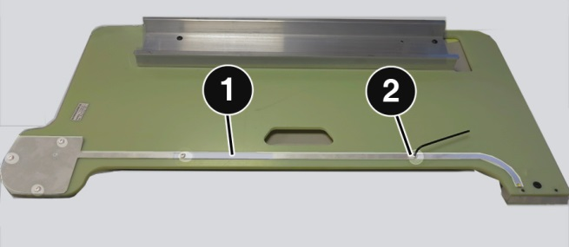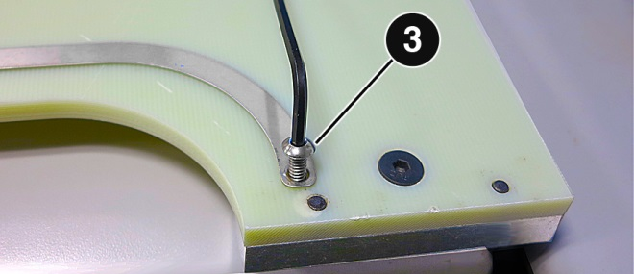

Please Contact The M&R Companies With Any Questions.
Page 2 of 2

