1. Identification

Product Name: Ink Mill UV Curable Ink, White
Product Identifier: Printing Ink; Mixture
Use: For Industrial Use Only by Qualified Personnel
Manufacturer: Ink Mill Corporation
Address: 6 Bay Rd.
Sanbornton, NH 03269
Emergency Phone Number: CHEMTREC: (800) 424-9300 (24 hrs., 7 days a week)
(+1) 603-217-4144
Date Updated: 06/14/16

2.Hazards Identification

GHS Classification: Acute Toxicity(Oral) Category 4
Skin Corrosion/Irritation Category 2
Serious eye damage/eye irritation Category 2A
Respiratory or Skin Sensitization Category 1A
Hazardous to the aquatic environment (Acute) Category 2
Flammable Liquids Not Classified
Acute Toxicity(Dermal) Not Classified
Acute Toxicity(Inhalation, mist) Not Classified
Germ Cell Mutagenicity Not Classified
Reproductive Toxicity Not Classified
Hazardous to the aquatic environment(Chronic) Not Classified
GHS Label elements:
Pictograms or Symbols:

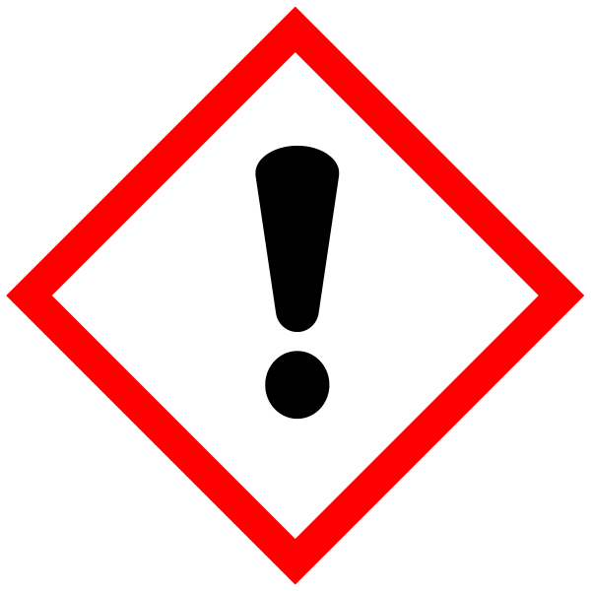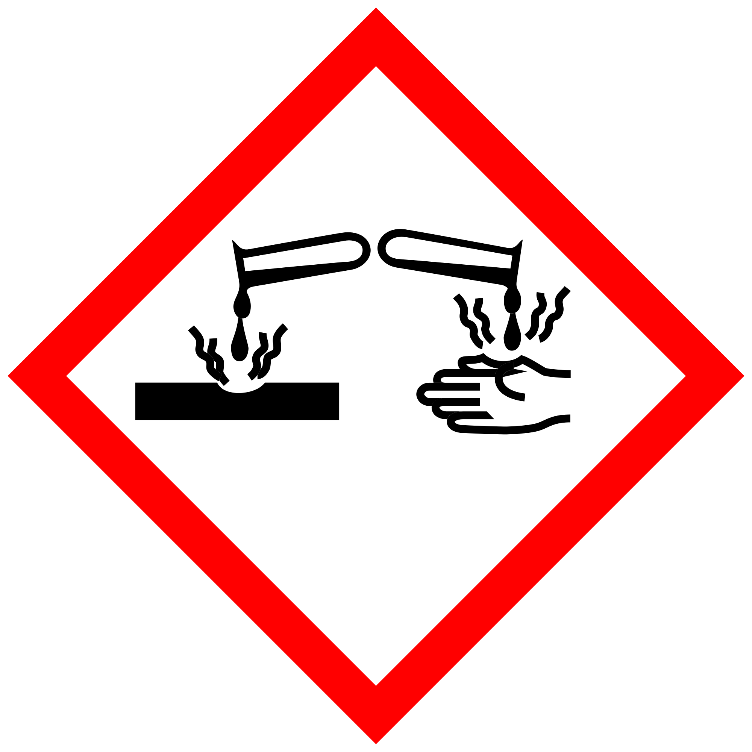
Signal Word: Warning Skin Corrosion/Burns

Hazard statements:
H314 : Causes Sever Skin Burns & Eye Damage.
H317 : May cause an allergic skin reaction.
H319 : Causes serious eye irritation.

Precautionary statements:

Prevention:
P261 : Avoid breathing gas/mist/vapours/spray.
P264 : Wash skin thoroughly after handling.
P272 : Contaminated work clothing should not be allowed out of the workplace.
P280 : Wear eye protection/ face protection.
P280 : Wear protective gloves.
Response:
P302 + P352 : IF ON SKIN: Wash with plenty of soap and water.
P305 + P351 + P338 : IF IN EYES: Rinse cautiously with water for several minutes. Remove contact lenses, if
present and easy to do. Continue rinsing.
P333 + P313 : If skin irritation or rash occurs: Get medical advice/ attention.
P337 + P313 : If eye irritation persists: Get medical advice/ attention.
P362 : Take off contaminated clothing and wash before reuse.
Disposal:
P501 : Dispose of contents/ container to an approved waste disposal plant.

3. Composition/Information on Ingredients

Hazards  Identification | CAS # | Weight % | GHS Classification
Alkoxylated Monomer Diacrylate  Tetrahydrofurfuryl Acrylate  Hexanediol Diacrylate  Vinylcaprolactam  Photoinitiator Blend | Proprietary Blend  2399-48-6  13048-33-4  2235-00-9  Proprietary | 20-30%  10-20%  5-10%  5-10%  1-10% | H314, H317, H319

4.First Aid Measures

Inhalation:
If inhaled, remove victim to fresh air.
Skin:
In case of contact, immediately flush skin with soap and plenty of water. Remove contaminated clothing and shoes.
Get medical attention. Wash clothing before reuse. Thoroughly clean shoes before reuse.
Eyes:
In case of contact, immediately flush eyes with plenty of water for at least 15 minutes. Get medical attention.
Ingestion:
If swallowed, DO NOT induce vomiting. Get medical attention. Never give anything by mouth to an unconscious
person. If victim is fully conscious, give a cupful of water..

5. Fire Fighting Measures

Flammable Properties: Flash Point: 118C (245F)

Extinguishing Media: Water spray, Carbon dioxide (CO2), Foam, Dry chemical
Protective equipment: Fire fighters and others who may be exposed to products of combustion should wear full fire fighting turn out gear (full Bunker Gear) and self-contained breathing apparatus (pressure demand / NIOSH approved or equivalent).

Further firefighting advice: Cool closed containers exposed to fire with water spray.
Fight fire from a protected location.
Closed containers of this material may explode when subjected to heat from surrounding fire.
Fire fighting equipment should be thoroughly decontaminated after use.

Fire and explosion hazards: When burned, the following hazardous products of combustion can occur:
Carbon oxides
Hazardous organic compounds
Polymerization is exothermic and can degenerate into an uncontrolled reaction.

6.Accidental Release Measures

Personal Precautions:
Evacuate personnel from the area. Shut off all sources of ignition; No flares, smoking, or flames in the area. Wear protective equipment.
Environmental Precautions:
Do not flush to sewer or waterways.
Dike with soil. Cover with a sheet to prevent expanding odor.
Methods for Cleaning up:
For small spills, use absorbent media. Dispose of the absorbent media according to local, regional, and national regulations.
For large spills, enclose the spilled liquid with sand. Recover the liquid while covering it with an oil-resistant antistatic sheet. Dispose of material according to local, regional, and national regulations.

7.Handling and Storage

In accordance with good industrial practices, handle with care and avoid personal contact.

Wear protective gloves, safety goggles, and other protective clothing.

Avoid contact with skin, eyes, and clothing.

Keep out of direct sunlight and away from heat source.

Keep tightly closed.

Keep from freezing.

Keep from oxidizing agents.

Use adequate ventilation.

8.Exposure Controls/Personal Protection

Airborne Exposure Guidelines:
Engineering controls:
Investigate engineering techniques to reduce exposures below airborne exposure limits or to otherwise reduce exposures. Provide ventilation if necessary to minimize exposures or to control exposure levels to below airborne exposure limits (if applicable see above).If practical, use local mechanical exhaust ventilation at sources of air contamination such as open process equipment.
Respiratory protection:
Avoid breathing processing vapor or mist. Where airborne exposure is likely or airborne exposure limits are exceeded (if applicable, see above), use NIOSH approved respiratory protection equipment appropriate to the material and/or its components. Consult respirator manufacturer to determine appropriate type equipment for a given application. Observe respirator use limitations specified by NIOSH or the manufacturer. For emergency and other conditions where there may be a potential for significant exposure or where exposure limit may be significantly exceeded, use an approved full face positive-pressure, self-contained breathing apparatus or positive-pressure airline with auxiliary self-contained air supply. Respiratory protection programs must comply with 29 CFR § 1910.134.
Skin protection:
Wear appropriate chemical resistant protective clothing and chemical resistant gloves to prevent skin contact.
Consult glove manufacturer to determine appropriate type glove material for given application. Avoid natural rubber gloves. Wear chemical goggles, a face shield, and chemical resistant clothing such as a rubber apron when splashing may occur. Rinse immediately if skin is contaminated. Remove contaminated clothing immediately and wash before reuse. Clean protective equipment before reuse. Provide a safety shower at any location where skin contact can occur. Wash thoroughly after handling.
Eye protection:
Where eye contact may be likely, wear chemical goggles and have eye flushing equipment available.

9.Physical and Chemical Properties of Ink

General Information: white liquid with mild odor.

pH: Not applicable
Boiling point: 94° C
Melting point: -71° C
Flash point: >119° C (closed cup)
Autoflammability: None
Oxidizing properties: None
Vapor density: > 3 (air = 1)
Density: 1.03-1.06 g/ml (20° C)
Solubility in Water: 18 g/L
Viscosity: 20 – 40 cps
VOC: None

10. Stability and Reactivity

Stability: Stable under normal conditions.

Conditions to avoid: Avoid heat and freezing temperatures.

Materials to avoid: Strong Oxidizing materials, peroxides, acids or iron.

Hazardous decomposition products: Will decompose to form carbon oxides when burned.

11. Toxicology and Health Hazards

Data on this material and/or a similar material are summarized below.

Acute toxicity
Oral:
Practically nontoxic. (rat) LD50 > 5.000 mg/kg.
Dermal:
May be harmful in contact with skin. (rabbit) LD50 = 3.650 mg/kg.
Inhalation:
No deaths occurred. (rat) 7 h > 0.41 mg/l. (vapor)
Skin Irritation:
Causes skin irritation. (rabbit) Irritation Index: 4.67 / 8.
Eye Irritation:
Causes serious eye irritation. (rabbit)
Skin Sensitization:
May cause allergic skin reaction. Guinea pig maximization test. (guinea pig) Skin allergy was observed.
Repeated dose toxicity:
Subacute oral administration / affected organ(s): liver, stomach / signs: changes in organ structure or function, changes in organ weights, clinical chemistry changes, reduced body weight
Developmental toxicity:
Reproductive/Developmental Effects Screening Assay. oral (rat) / No birth defects were observed.
Reproductive effects:
Reproductive/Developmental Effects Screening Assay. oral (rat) / No toxicity
Human experience
Skin contact:
Skin allergy was observed.. (based on reports of occupational exposure to workers) (studied using human volunteers) (subjects with dermatitis or eczema)

12. Ecological Information
Chemical Fate and Pathway
Data on this material and/or a similar material are summarized below.

Biodegradation:
Readily biodegradable. (28 d) biodegradation 60 - 70 %
Octanol Water Partition Coefficient:
log Pow = 2.81

Ecotoxicology
Data on this material and/or a similar material are summarized below.

Aquatic toxicity data:
Toxic. Leuciscus idus (Golden orfe) 96 h LC50 = 4.6 - 10 mg/l
Aquatic invertebrates:
Toxic. Daphnia magna (Water flea) 48 h EC50 = 2.6 mg/l
Algae:
Toxic. Desmodesmus subspicatus (green algae) 72 h EC50 = 1.5 mg/l
Microorganisms:
Practically nontoxic. Activated sludge 30 min EC50 (Respiration inhibition) = 270 mg/l

13. Disposal Considerations
Waste from residues:
Burn in a chemical incinerator equipped with an afterburner and scrubber. Consult an expert on the disposal of recovered material.
Any contaminated packaging:
Do not put other material into the used container and do not use it for other purpose. Wash the inside of the container before disposal.
Comply with all federal, state and local regulations.
Do not dump this product into sewers, on the ground or into any body of water.
14. Transport Information
The UN classification number
UN Class: Not applicable
UN Number : Not applicable
Proper shipping Name: Not applicable
Packing Group: Not applicable
Marine Pollutant: Not applicable

Specific precautionary transport measures and conditions:
Avoid falling, dropping, shocking and dragging a container.
Protect a container from direct sunlight.

By 49 CFR 172.101 published by the US department of Transportation, this product is not considered Dangerous Goods.
DOT listing: None
Packing group: None
DOT Labels required: None
Marine pollutant: Components are not listed as marine pollutants.

Sea transport
IMDG
Not classified as a dangerous good under transport regulations

Air transport
IATA/ICAO
Not classified as a dangerous good under transport regulations

15. Regulatory Information

All components are on TSCA, EINECS/ELINCS, AICS, DSL, ENCS, and ECL.
All components are REACH registered and not listed in Annex XIV of EC No., 1907/2006 REACH Restriction.
All components are not listed on SARA Title III 313.

Regulatory information with regard to this product in your country or region should be examined by the end user.

16. Other Information

The above information is believed to be correct but does not purport to be all-inclusive and shall only be used as a guide. Ink Mill Corporation offers this information as a service to our customers and shall not be held liable for any damage resulting from handling or from contact with the above product.

END OF SDS

